**Family Sharing App: Receive a Name**

**Revision History**

**6/6/2018** Version 1

**6/30/2018** Version 2

**7/18/2018** Version 3 (This document)

**Major Changes Since Last Version**

Changed specification for header and footer size. The purpose for doing this is to give more space to the reserve button, so users do not accidentally hit the next tab.

I equalized the header and footer size to give the layout continuity.

Only these changes will have handwritten notes describing their specification.

**Executive Summary**

The Family Sharing app makes sharing ancestors’ temple work fun and easy. The user simply selects what ancestors they want, and the user is prepared to do the work for those ancestors.

**Persona**

Sue Harris is a 42-year-old stay at home Mom who owns a card making business on the side. She has 5 children ranging from ages 5 to 17. Sue loves family history work and is an active member of her church. Sue also loves her living family members. Sue works with her family members in bringing ancestors either she or they find to the Temple at least once a month.

**Scenario**

Sue and her husband are on their way out of the house to go to the Temple tonight. Sue forgot to find ancestors to bring for her trip to the Temple. Sue opens the app and is presented with a list of ancestors that her family has shared with each other. Sue chooses the top male and female ancestor and then presses a button to take these ancestors to the Temple. The app makes the code Temple Workers will use to print the ancestor’s temple work. Sue and her husband are off to the Temple with their ancestors in hand.

**Prototype**

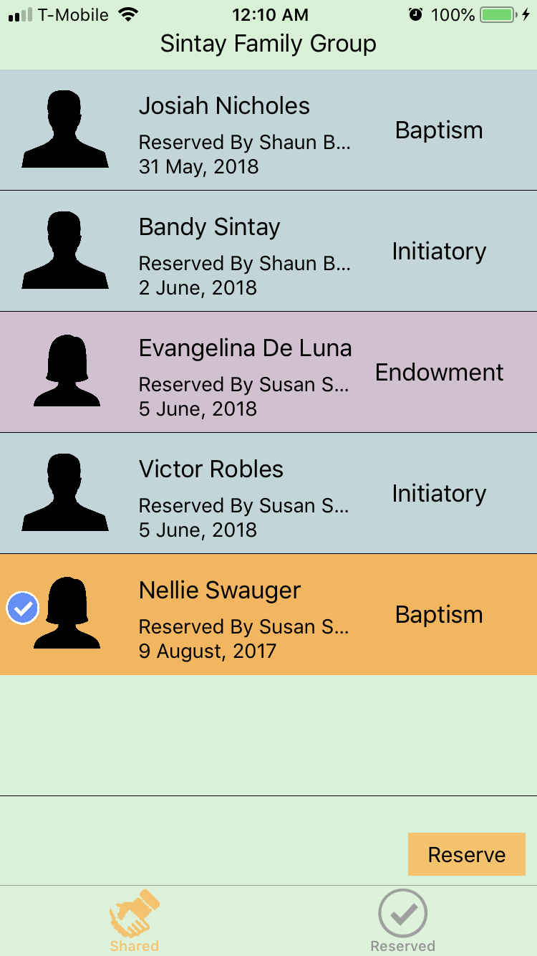

**Criteria**

*Priority 1*

* The process of receiving names should be a short and simple process for the user.
* A novice user must be able to receive an ancestor’s name the first time.

*Priority 2*

* The process of receiving a name should be something like the user has experienced before.
* The user should feel it easy to receive a name to do work for in the Temple.
* The user should recognize all the controls and what they should do.
* The user should enjoy using the application.

*Priority 3*

* The user should have confidence in the application while receiving an ancestor’s name.

**Detailed Design**

**1.0 - General Overview Flow Diagram**

The following is a diagram detailing the relationships between the different views of the feature:

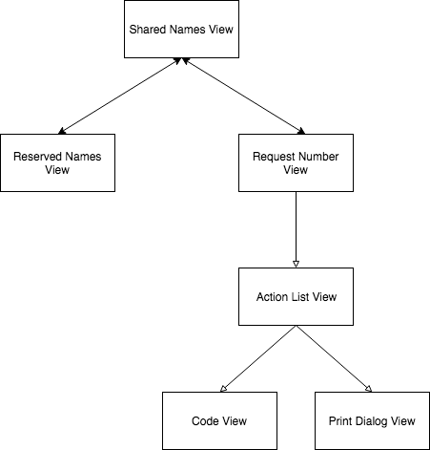

**2.0 - Shared Names View**

The following image shows how the shared names view will display.

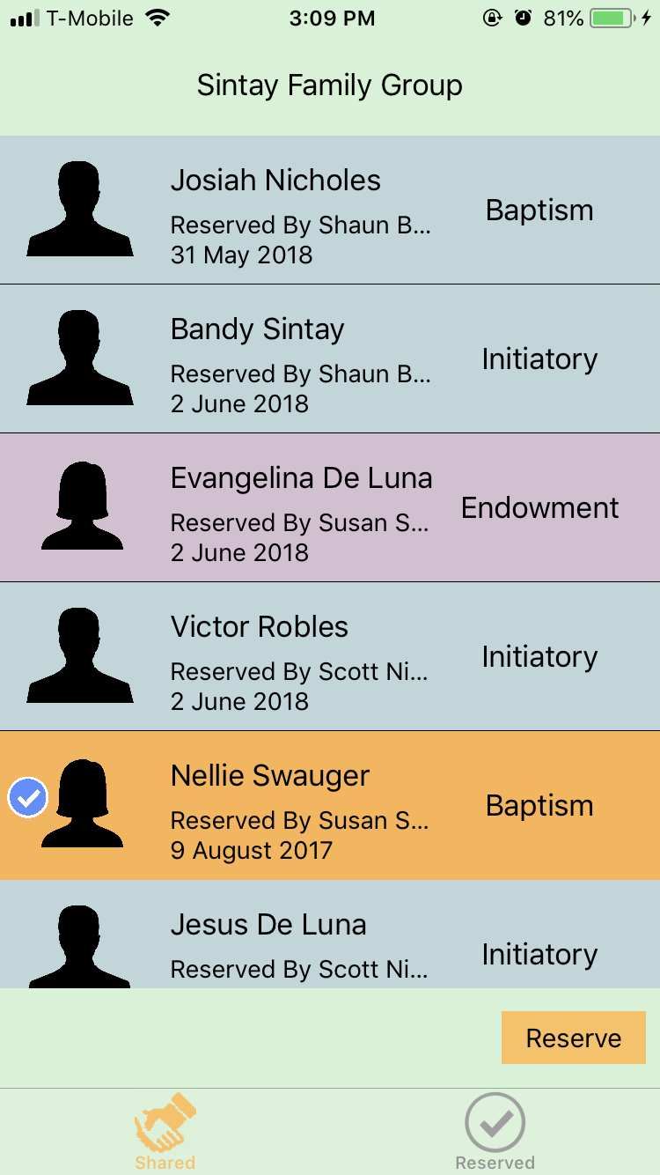

|  |  |  |
| --- | --- | --- |
| **Label Number** | **Description** | **Specification** |
| 1 | iOS Status Bar. This bar is provided by the Operating System. This bar provides device information such as the battery power and cell carrier. | None |
| 2 | Group Name bar. This bar simply displays the name of the group that shares ancestor’s names. | See handwritten notes.  Width: 100% of screen width.  Text box:   * Text may extend to 100% of the screen size * San Francisco Font (SF) * 17 pt. font |
| 3 | Ancestor Name Cell. This cell provides basic information on an Ancestor’s temple work. | See Section 4.0 |
| 4 | Navigation bar. This bar allows the user to navigate to the two main screens of the app (Shared Names View and Reserved Names View). | See Section 5.0 |

**2.1 Action List View**

The following image details the action list view. This view appears after the Reserve button is pressed on the Shared Names View.

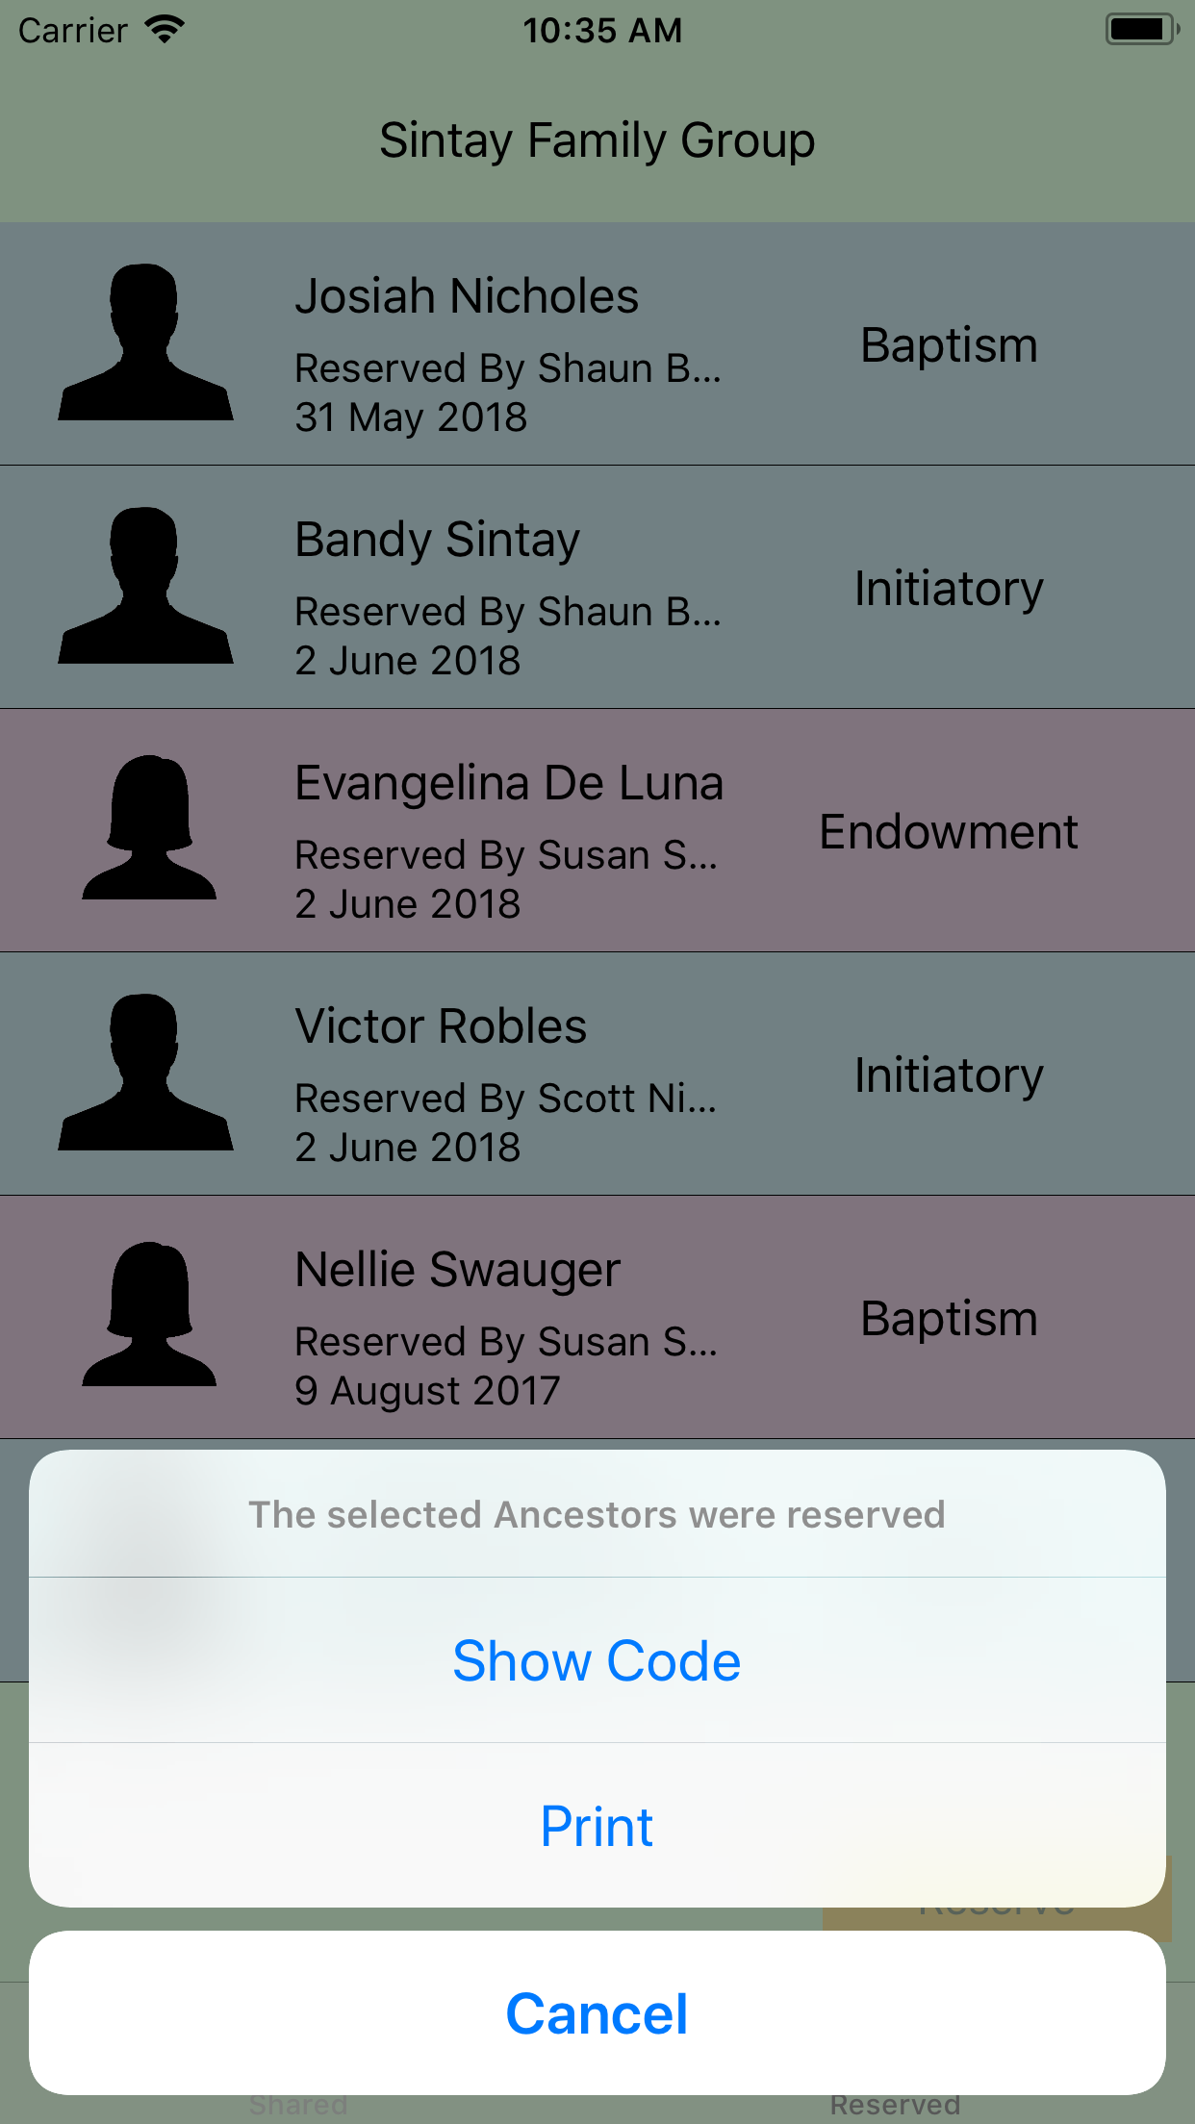

**2.2 – Code View**

The following image shows how the code view will display. This view is displayed after the user presses the Show Code button on the Action List View.

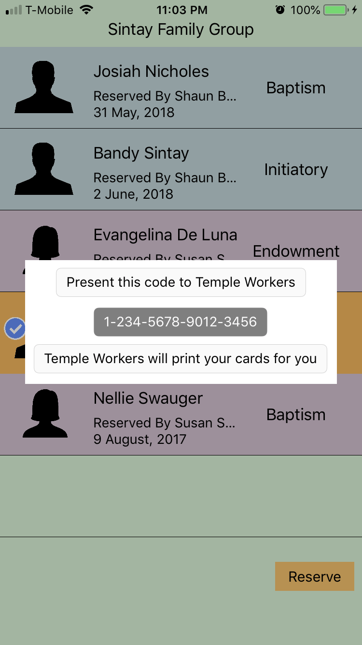

**2.3 – Print Dialog View**

The following image shows how the print dialog screen will appear. This view appears after the user presses the Print button on the Action View.

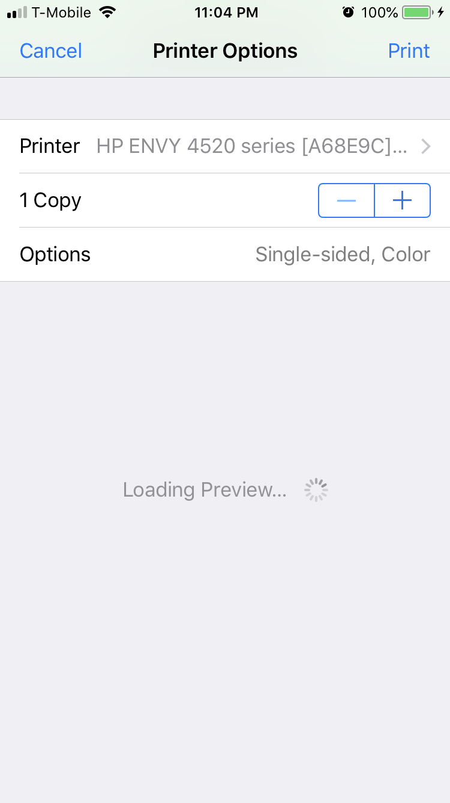

**3.0 – Reserved Names View**

The following image shows how the reserved names view will display.

The specification for this view is the same as the specification for the Shared Names View, with exceptions handwritten.

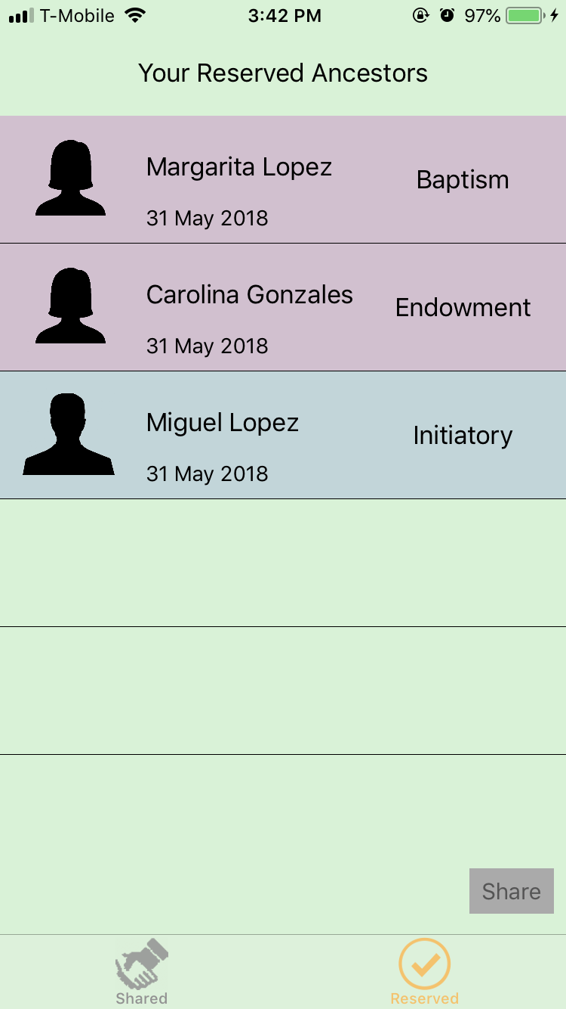

**4.0 – Ancestor Name Cell**

The following diagram details the ancestor name cell specification.

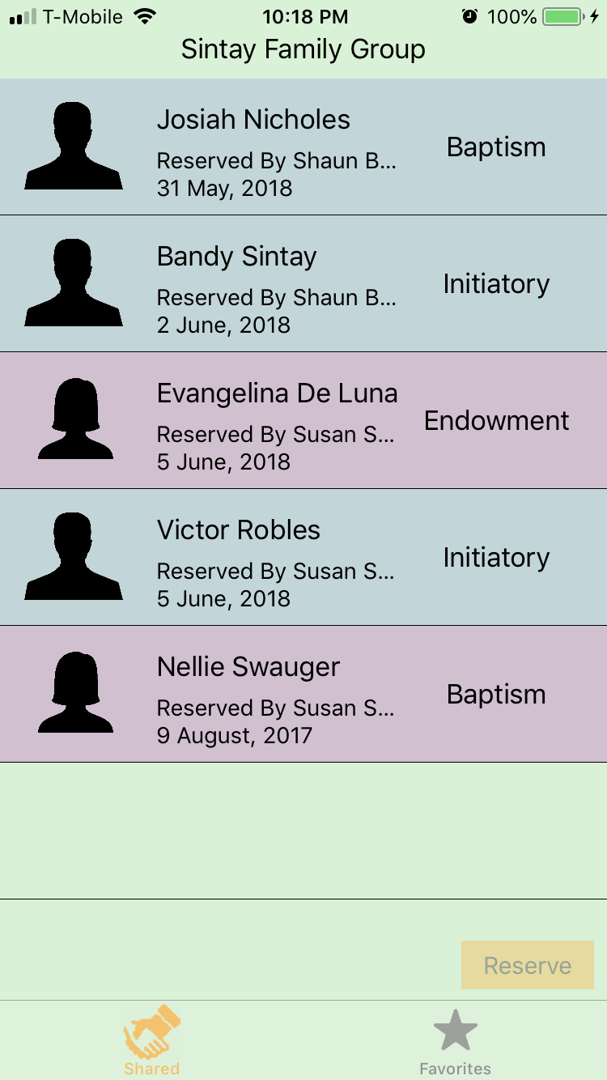

The following image is placed to the side of the image when the cell is selected.



|  |  |  |
| --- | --- | --- |
| **Label Number** | **Description** | **Specification** |
| 1 | Rectangular cell body. | See handwritten notes.  Color Fill:   * For male ancestors, Red: 125 Green: 126 Blue: 232 Alpha: 0.25 * For female ancestors, Red: 217 Green: 38 Blue: 196 Alpha: 0.25 |
| 2 | Ancestor Picture Icon. | See handwritten notes.  Default Image:   * For male ancestors, * For female ancestors, |

**5.0 – Navigation Bar**

The following diagram details the navigation bar specification. This bar appears at the bottom of each view, allowing the user to transition between the two main views of the application.

